1. MODULARISATION TECHNIQUES
2. FUNCTION MODULES

INPUT:

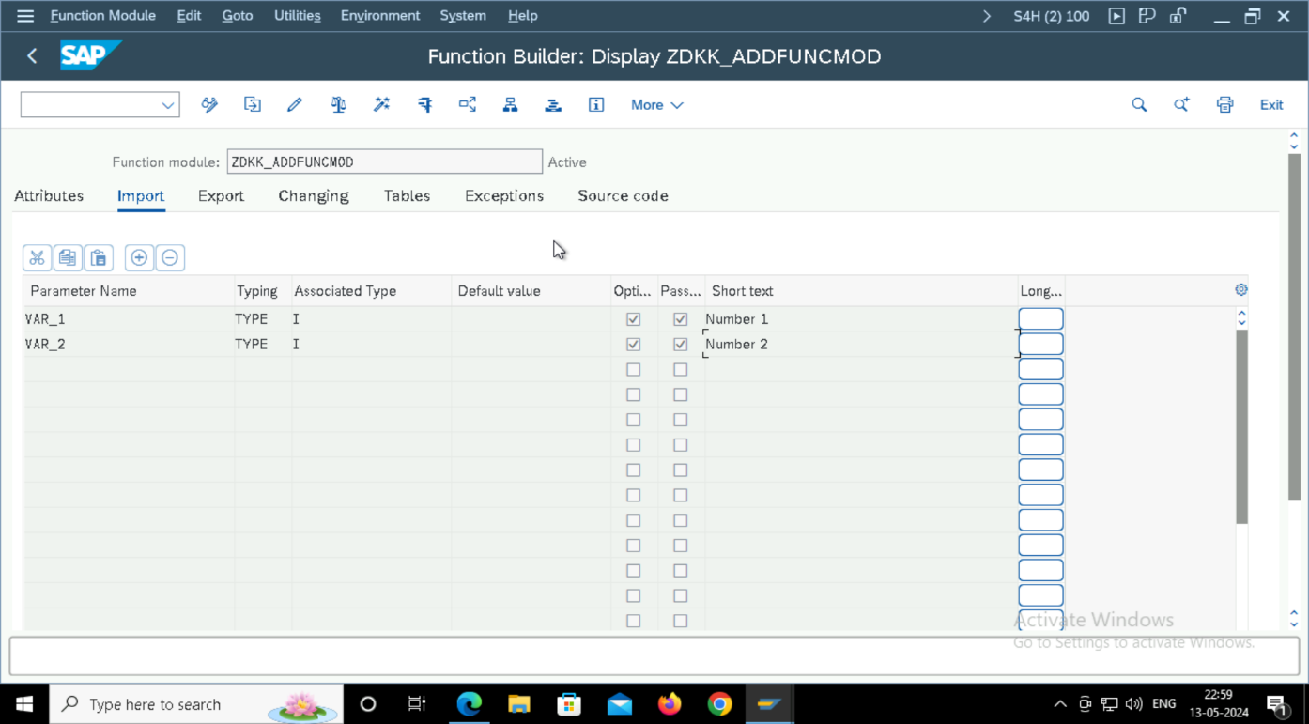

Output:

1. SUBROUTINES

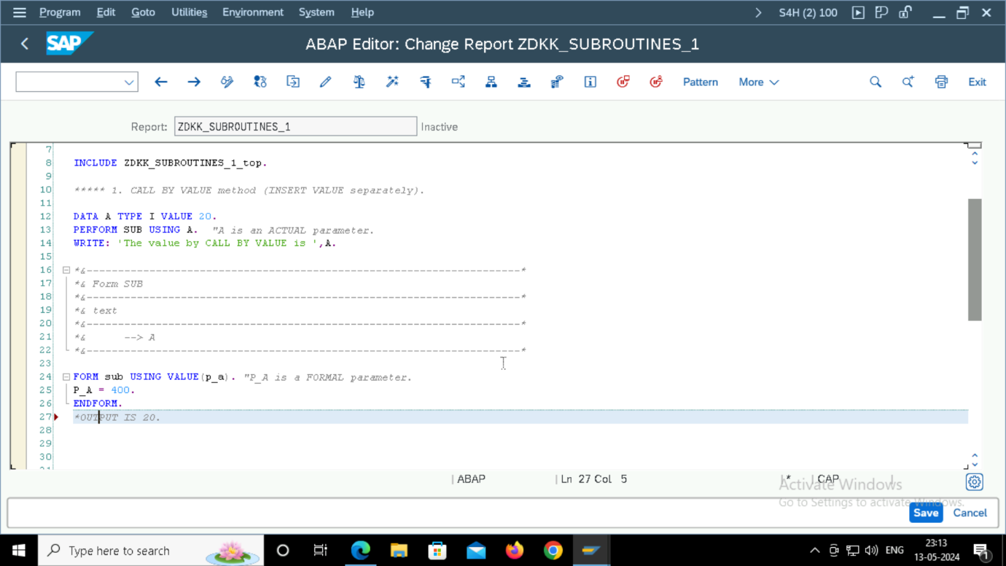

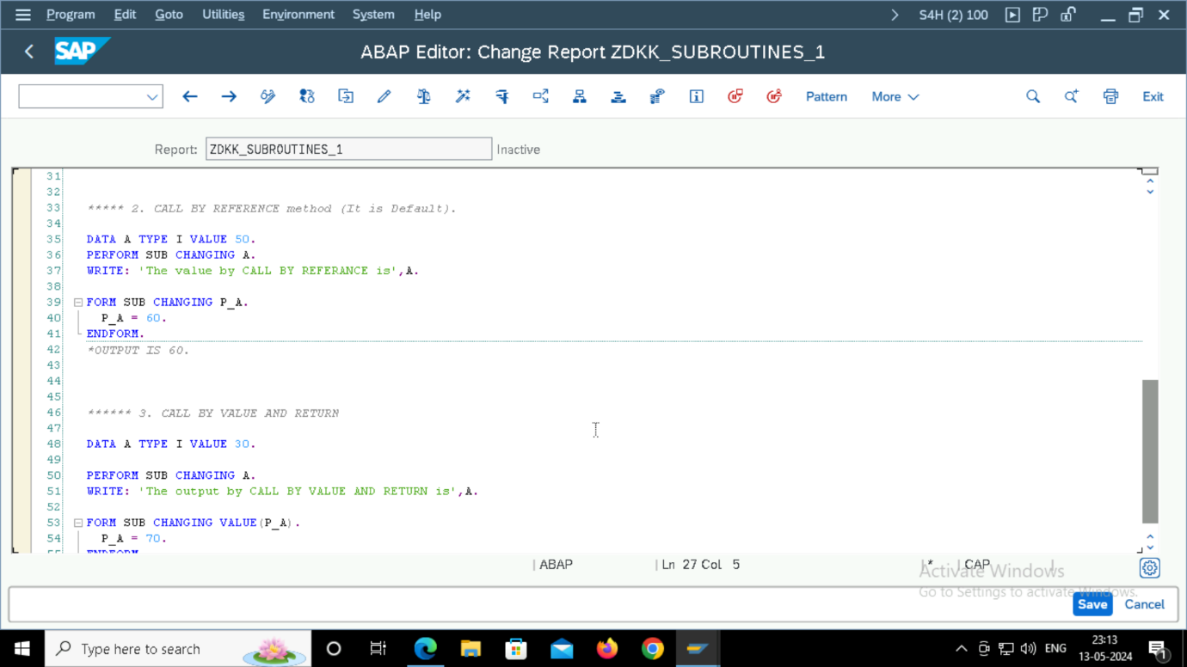

1. INCLUDES:

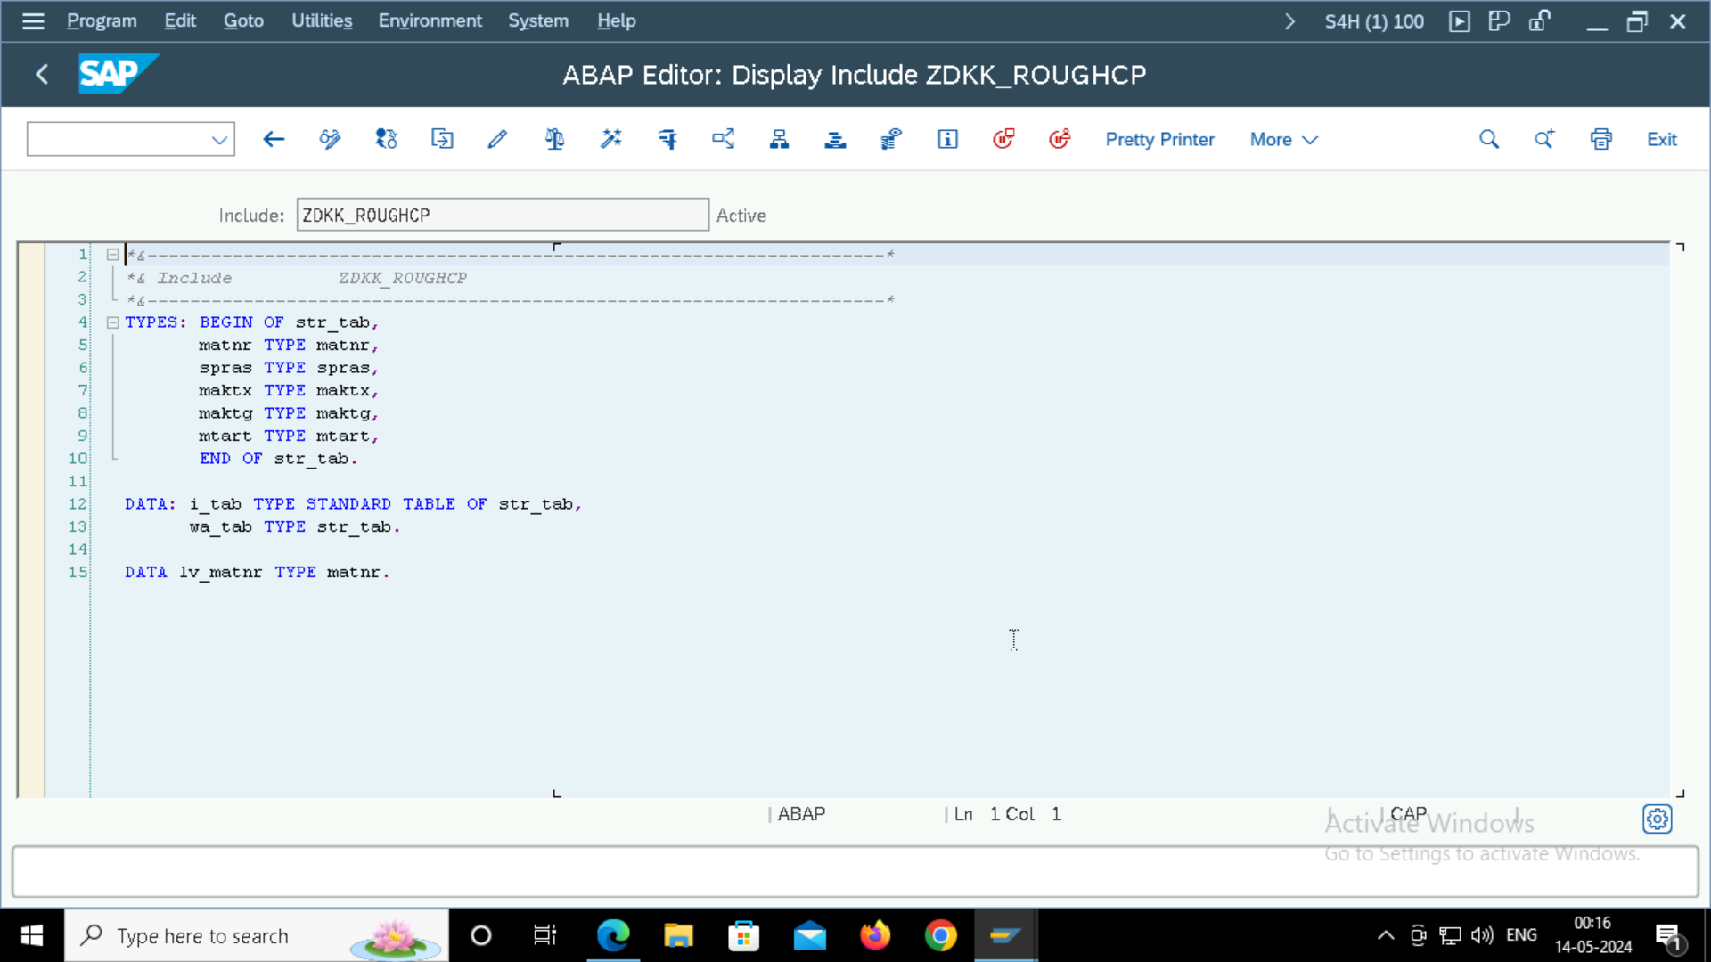

1. CLASSICAL REPORTS:

INPUT:

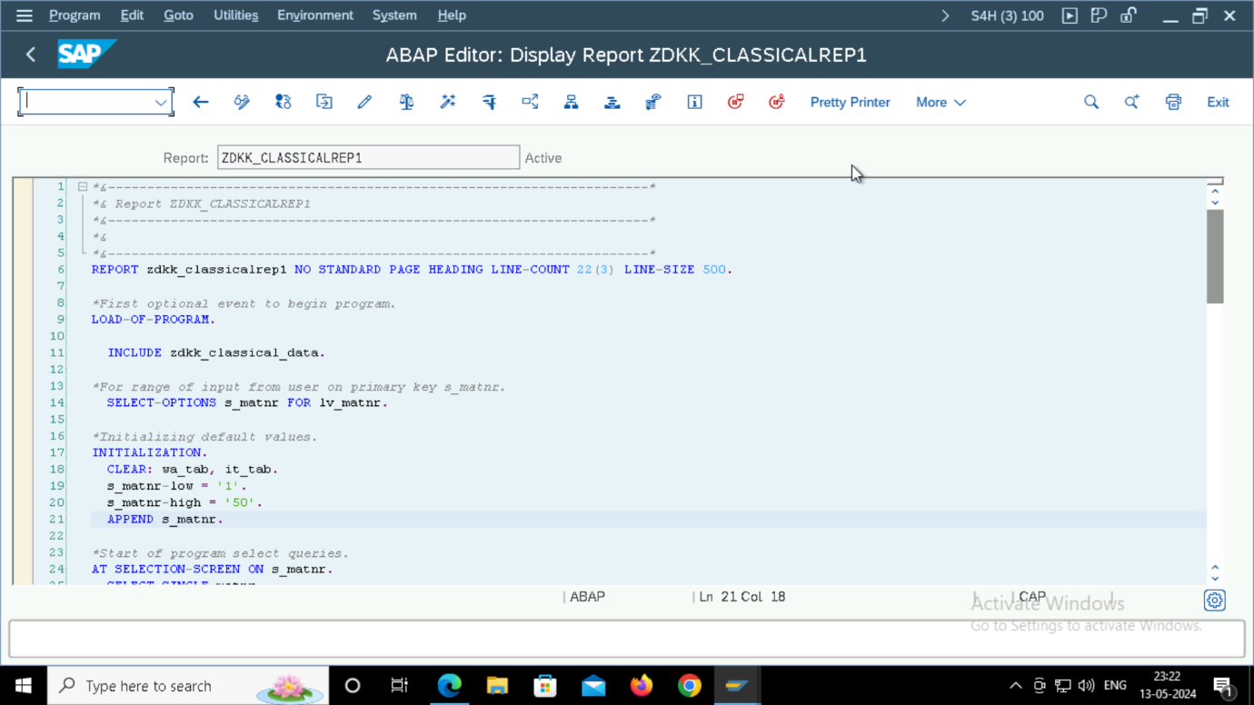

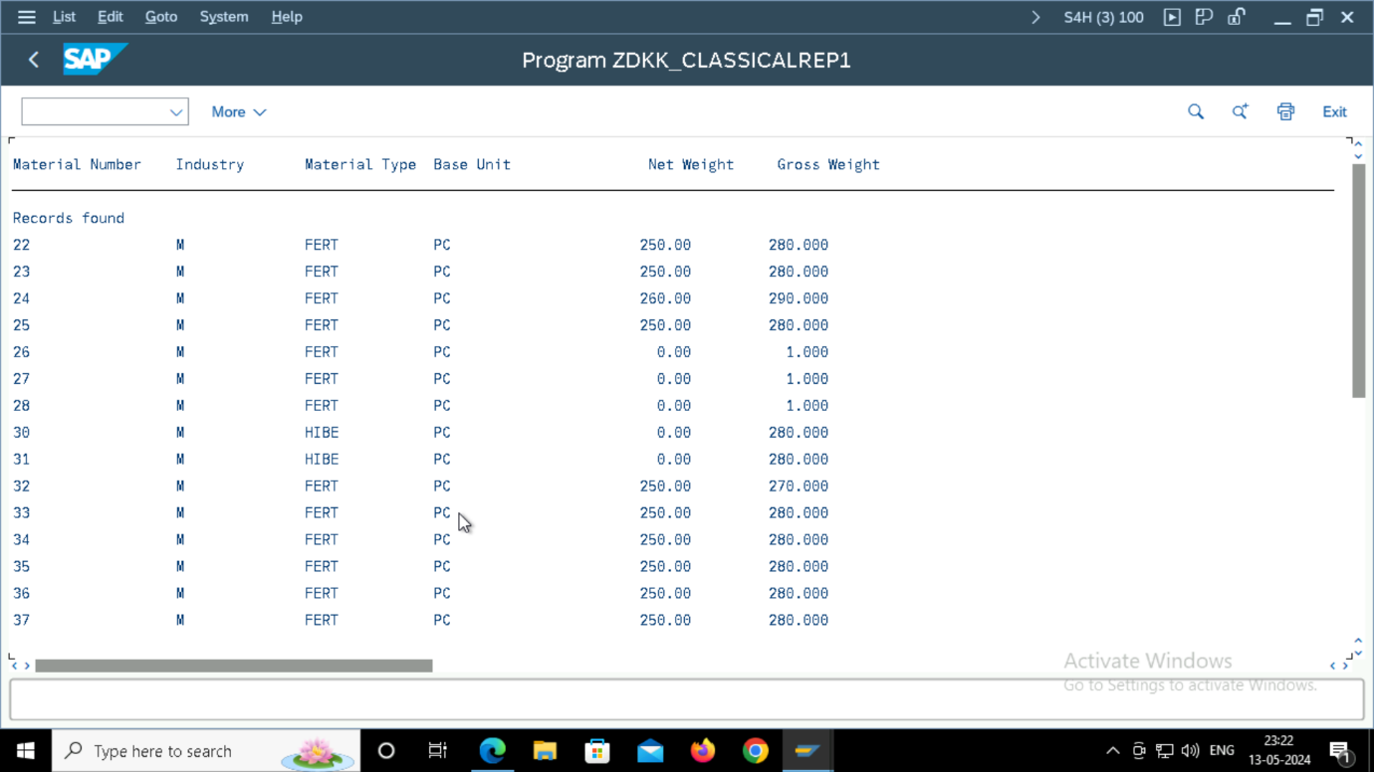

1. Interactive REPORTS:

At Line Selection:

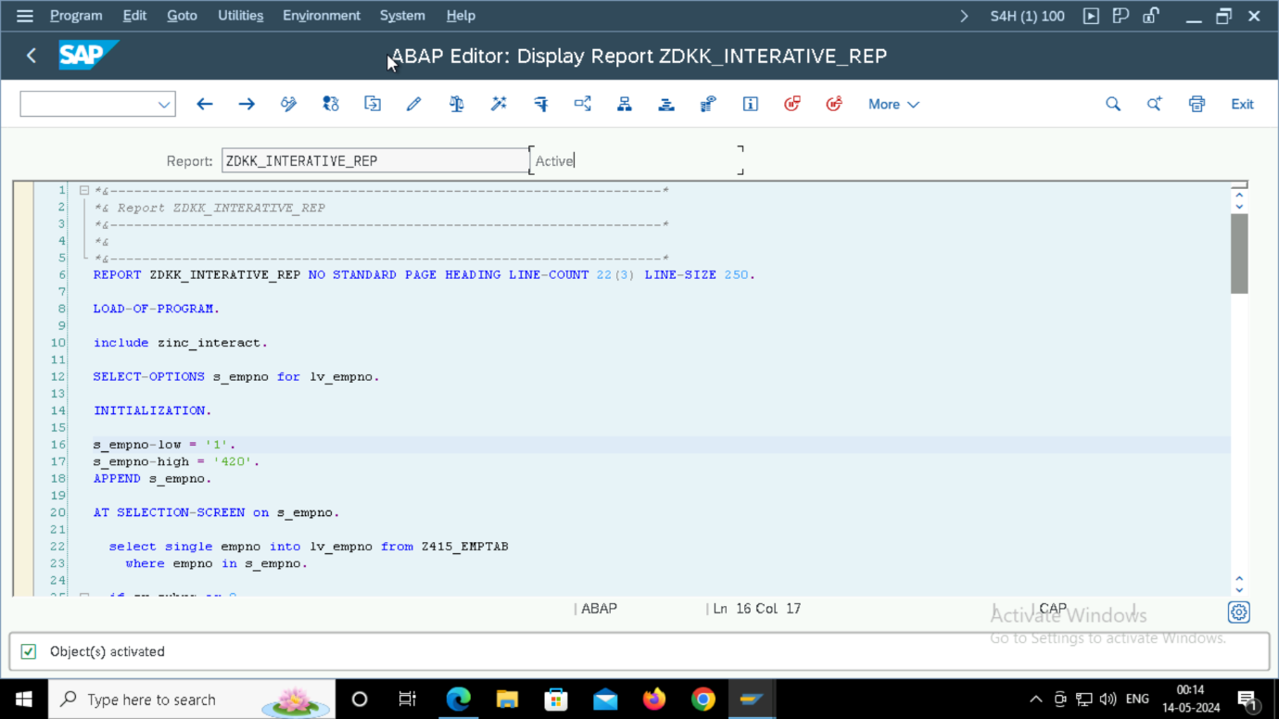

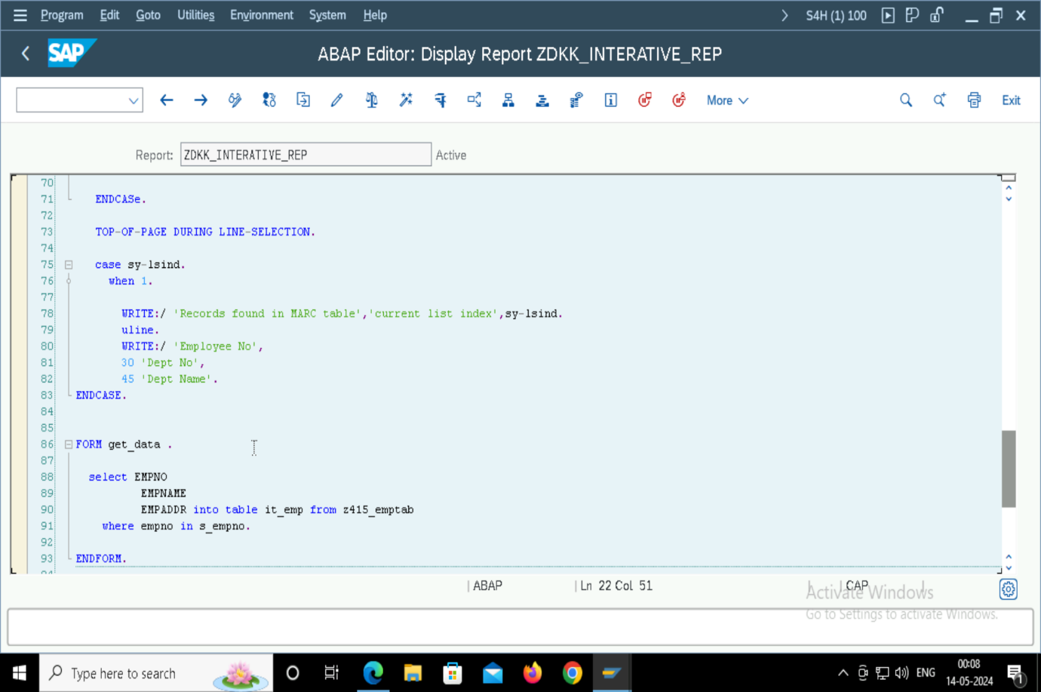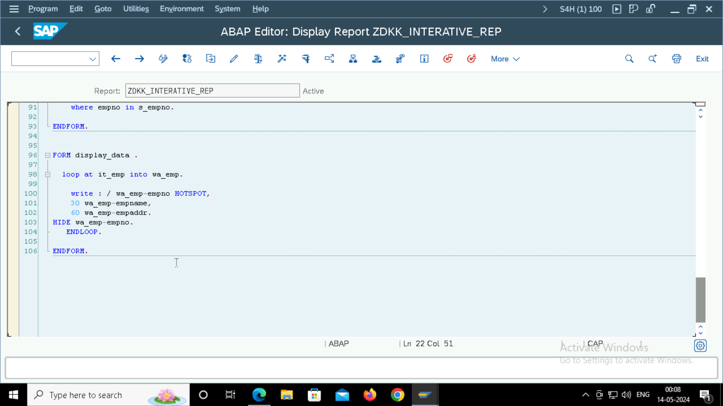

At User Command:

OUTPUT:

